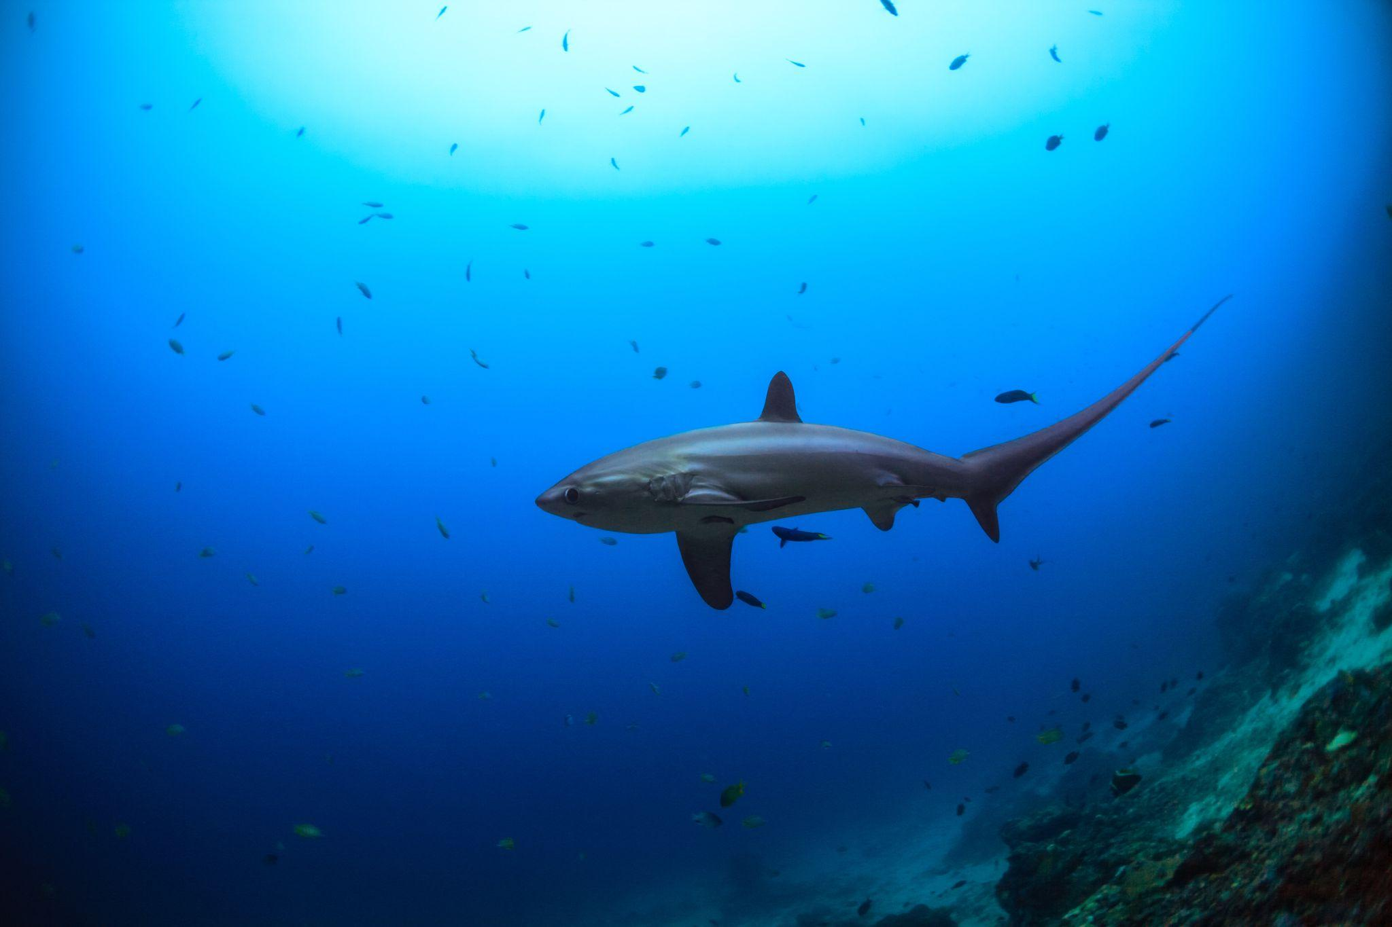



6D5N THE LEGENDARY THRESHER SHARKS OF MALAPASCUA
马拉帕斯卡岛-长尾鯊潜旅



T/C: GA-SIDM | UPDATED: 22 AUG2024

Malapascua is the only place in the world where the magnificent thresher shark can be seen daily. Apart from thresher shark, you'll have chance to see whitetip sharks as well as other sharks and large rays; wrecks and reefs; wall dives and muck dives; beautiful unspoiled coral gardens, mating mandarin fish, frogfish, seahorses, cuttlefish, nudibranchs galore, endless crustaceans, amazing macro and much more…

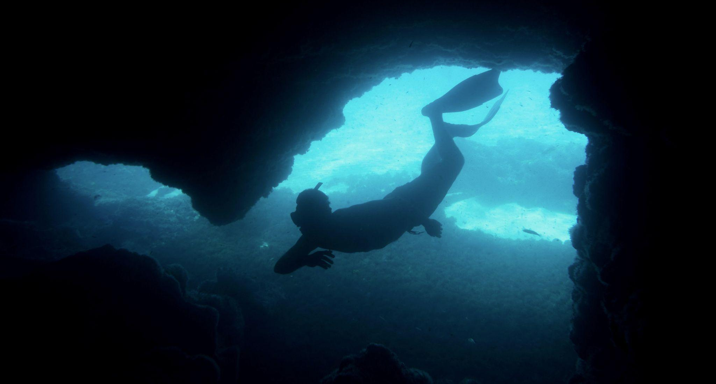
Malapascua

Day 1: Arrive Cebu Airport (CEB)
抵达宿务国际机场
On arrival Cebu Airport (Recommended arrival time in morning or before 11am), transfer from airport to New Maya Port (Approx. 3-4 hours). Take a private boat enter to Malapascua Island (Approx. 30 minutes). Check-in hotel.
抵达宿雾机场后（建议到达时间为早上或11点之前），将有代表迎接您并送往新玛雅港（约大3-4小时），乘坐私人船只进入马拉帕斯加岛（约大30分钟）。抵达后，送往酒店办理入住手续。

Day 2: Diving Day | Kimod Shoal & Monad Shoal
基姆德浅滩和莫纳德浅滩

05.30hr, proceed to Kimod Shoal for dive (Thresher Shark). 10.00hr, proceed to Monad Shoal for dive (Tiger Shark/Bull Shark). Kimod is one of the most famous shark watching dive sites because the dive site area is a cleaning station for thresher sharks. Every morning from 5~6 o'clock, the thresher sharks line up to clean their bodies. Monad offers opportunity to see tiger or bull sharks recently.

换上潜水服后，早05.30，前往基姆德浅滩潜水（长尾鲨）。早10.00，前往莫纳德浅滩潜水（虎鲨/牛鲨）。基姆德浅滩是最著名的鲨鱼观赏潜水地点之一，因为潜水地点区域是长尾鲨的清洁站。每天早上5~6点，长尾鲨排着队清理身体。在莫纳德浅滩有机会可以看到虎鲨/牛鲨。

Meals: Breakfast, Lunch, Dinner
用餐：早、午、晚

Komodo National Park

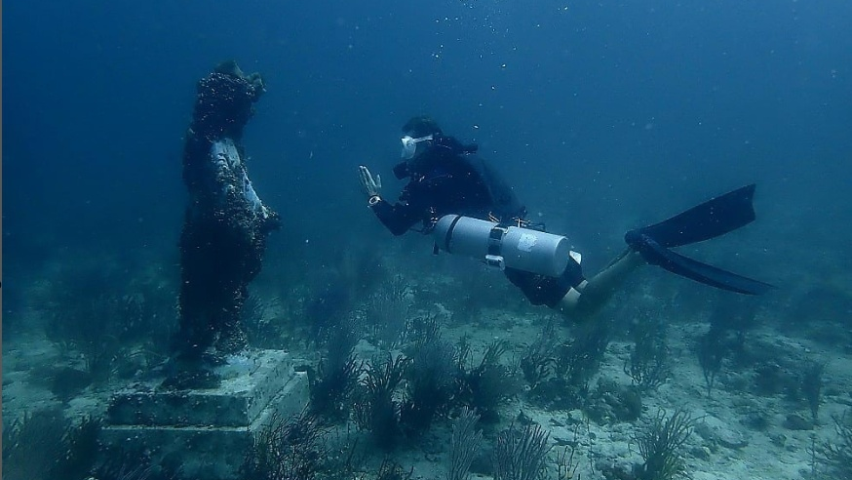
Gato Island

Day 3: Diving Day | Gato Island
猫岛

09.00hr, proceed to Gato Island for dive (White Tip Shark, Tunnel Dive). After that diving around that island (Local dive). Gado island not only a marine life sanctuary, but also a sanctuary for sea snakes. The dive site has a beginner-friendly underwater tunnel about 30 meters long and is full of soft corals, most notably white-sided dolphins, bamboo sharks and abundant soft corals, nudibranchs, seahorses and rays.

换上潜水服后，早09.00，前往猫岛潜水（白鳍鲨，隧道潜水）。猫岛不仅是海洋生物保护区，也是海蛇的避难所。该潜点有一个适合初学者的海底隧道，长约 30 米，软珊瑚遍布，最为出名的是栖息在此地的白鳍豚、竹节鲨及大量软珊瑚、海兔、海马和鳐鱼等。

Meals: Breakfast, Lunch, Dinner
用餐：早、午、晚

Day 4: Diving Day | Kalanggaman Island
卡郎加曼岛

08.00hr, proceed to Kalanggaman Island for dive (Wall Dive). Afternoon 05.30PM, proceed to night dive. Kalanggaman Island is known as the "little sack" and some people call it the "romantic island", whether it is the scenery of the island or the creatures under the sea, it is worth exploring. The underwater overhanging cliffs extend to the depths of the blue sea, due to the depth is only 15~20 meters with sufficient sunlight, the dive site is full of beautiful corals and abundant marine life. Sponges thrive here, with large barrel sponges and tube sponges are common, and schools of marquise jackfish and damselfish bream.

换上潜水服后，早08.00，前往卡郎加曼岛潜水（壁潜）。午05.30，前往夜潜。卡郎加曼岛有“小麻袋”之称，也有人称其为“浪漫岛”，无论是岛上的风景还是海底的生物，都值得探索。水下悬岩峭壁延伸到湛蓝大海深处，由于深度只有 15~20 米，日照充足，因此该潜点遍布着漂亮的珊瑚和丰富的海洋生物。这里海绵生长繁茂，大型桶海绵和管海绵比较常见，还有成群的马眼杰克鱼和雀鲷穿梭其间，非常漂亮。

Meals: Breakfast, Lunch, Dinner
用餐：早、午、晚

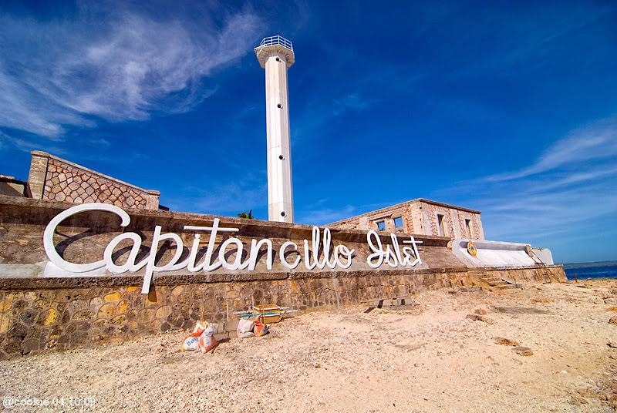
Capitancillo Islet

Day 5: Diving Day | Capitancillo
珊瑚島

08.00hr, proceed to Capitancillo for dive (Wall Dive). Capitancillo takes its name from the famous U.S. Navy Captain Cillo, who sailed his ships to this isolated and stunning island during World War II. Don’t forget to take a beautiful picture of the island's military relics towering in the middle of the sea.

换上潜水服后，早08.00，前往珊瑚島潜水。Capitancillo 小岛的名称來自著名的美国海軍上尉西洛（Cillo），在第二次世界大战期间将船只驶向了这个孤立又令人惊艳的小岛。岛上的军事遗迹耸立在大海中央十分美丽又有冲突感，拍起照來每张都很美又有故事性。

Meals: Breakfast, Lunch, Dinner
用餐：早、午、晚

Day 6: Malapascua – Cebu Airport Departure
马拉帕斯加岛 – 宿务国际机场 – 回程

After Breakfast, check out hotel then transfer to New Maya Port. Then transfer to Cebu airport for flight departure.

早餐后退房，然后前往新玛雅港。然后送往宿务机场乘搭客机。

Meals: Breakfast
用餐：早

*Sequence of itinerary subject to arrangement*
*Sequence of itinerary subject to arrangement*


Important Notice:

• Total 15 boat dives (provide scuba tanks, weights, weight belts).
• Divers should bring own equipment
• Extra charge:
Rental equipment (including BCD/regulator) : USD 15 per pax per day
Dive computer : USD 8 per pax per day
Torch : USD 6 per pax per day

Hotel | Traveling Period: 01 SEP 2024 – 20 DEC 2025  [Normal Season]
Hotel | Ground Arrangement – MYR (Per Person)
Hotel | Twin Sharing
Hotel | GV 8
3* KOKAY’S MALDITO | RM 5,888
Remarks:

1) Private Tour Min. GV.8 per booking.
2) Please ensure your flight schedule tallies with our tour schedule. Any missed flight will not be refunded.
3) Non-refundable deposit of RM 2000/Pax upon booking confirmation. Full payment must be made 45 days before departure.
4) 5 Nights’ Kokay’s Maldito Beach Resort - Premium Room (shared room) with daily Breakfast as per itinerary. (Basic Hotel with clean, neat and limited facilities)
5) All airport and boat transfers as per above itinerary
6) Maya Port last boat at 17.00hr
7) Fullboard (lunch & dinner)
8) Marine Park fee included
9) Entrance fee to Kalanggaman & Capitancillo
10) Tour packages are only applied for Malaysian passport holder.
11) Prices are quoted per person in Ringgit Malaysia (MYR) & subject to change without prior notice.
12) Hotel rooms are subject to availability. If selected hotel unavailable, others similar accommodation will be provided with different price apply (if any). * Hotel check in time 15.00 – onwards. Check out time 11.00.
13) No time different between Philippines and Malaysia, currency PHP - Philippine Peso.
14) No services has been blocked under your favor, subject to availability upon your confirmation.
15) Tipping is up to individual.

For Enquiry, please check the: https://www.goldendestinations.com



